Output 10 SQL Assigmnet

/\* Day 10 Assignment */*

*/* 1. Write a function to Calculate the total stock value for a given category: \*/

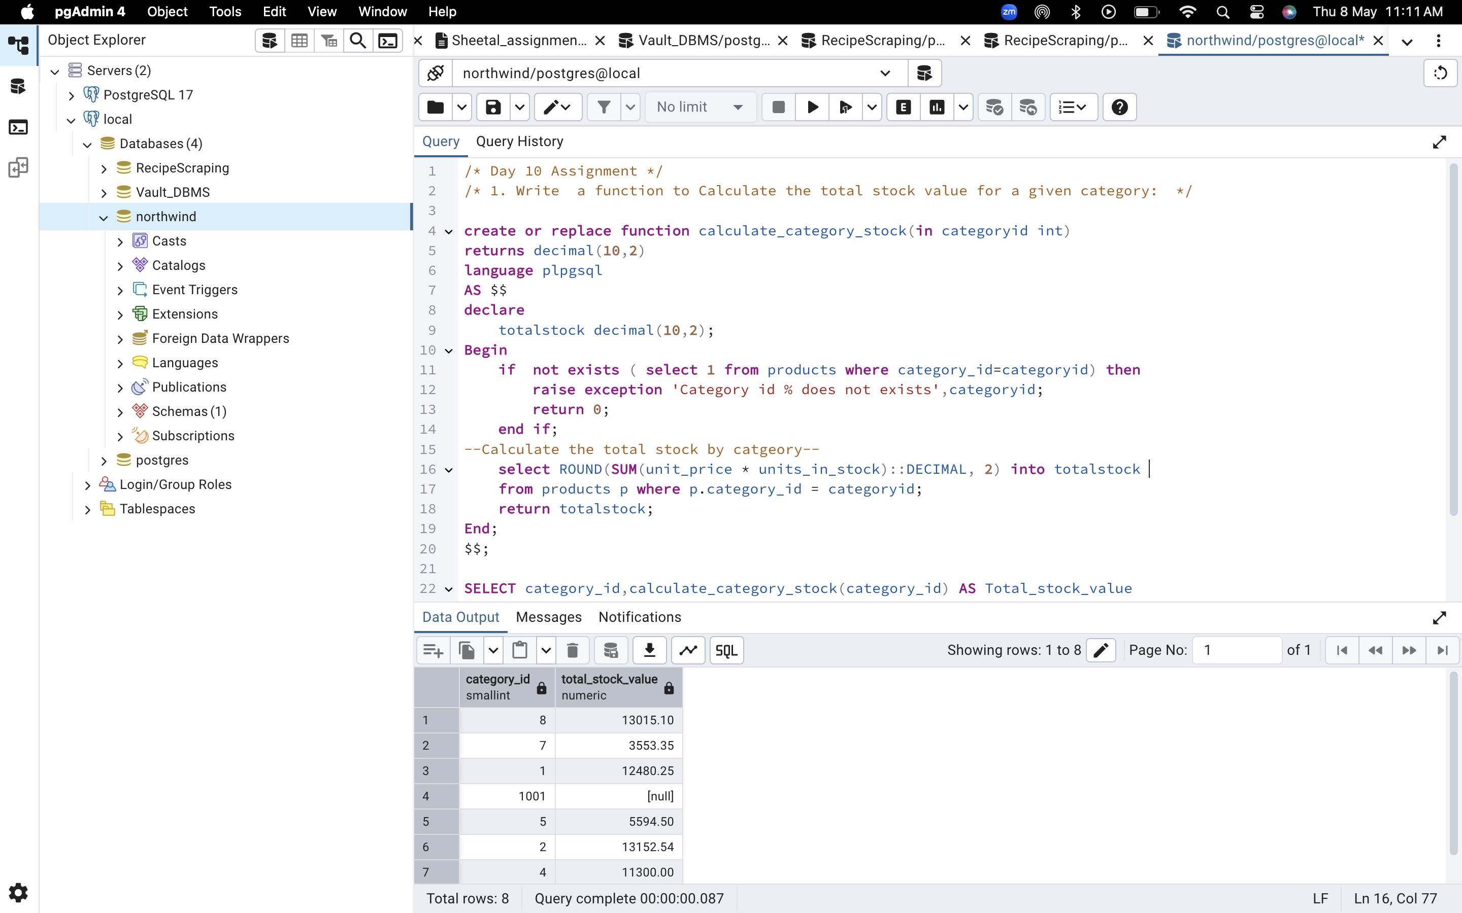

/\* 2 Try writing a cursor query which I executed in the training. \*/

